Motivation

Creating a program is an exciting thing to do, but being able to improve that program and utilizing better ideas gives you a sense of accomplishment. Sorting items, for instance, can be a very interesting thing to do with data or numbers… especially if you created the program doing the sorting. However, there is a more interesting aspect to sorting, and that is efficiency. It is one thing to create a program that utilizes a sorting algorithm, but it is another thing to come up with a program that utilizes the most efficient sorting algorithm producing the quickest sorting time. The problem I have explored is to decide which algorithm, Insertion Sort or Merge Sort, is more efficient and for what sizes each are most efficient. By the end of this experiment, one should be able to tell when they should use Insertion Sort and when they should use Merge Sort.

Background

Insertion Sort and Merge Sort are both good algorithms depending on when they are implemented. The task I will be performing is to decide when each of these algorithms should be implemented in order to produce the best results. For instance, when a large amount of items needs to be sorted very quickly, a person would want to use a program that takes three seconds instead of three minutes. Finding the better algorithm for the job isn’t always an easy thing to do, however. A person needs to take into account many things, for instance what sizes the program will usually be sorting. A common misconception is that a faster computer will solve an algorithm quicker; however, this is not the case. Algorithms rely on efficient programming more than just a fast computer. This is why I will be running this experiment.

Psuedocode for Insertion Sort

For j from 2 to n
{
For b ← 1 to i // Checks during maintenance
assert(array1[b-1] <= array1[b])
key ← A[j]
i ← j – 1
while i > 0 And A[i] > key
{
A[i+1] ←A[i]
i ← i- 1
}
A[i+1] ← key
}
For b ← 1 to I // Checks for termination
assert(array1[b-1] <= array1[b])

Pre-Condition: Sequence of numbers {a₁, a₂,…., a_{n}} = A
Post-Condition: a’₁ < a’₂ < …. < a’_{n} and a’ are permutations of original a.
Invariant: a’₁ < a’₂ < …. < a’_{j-1} and a’ are permutations of original a.

Psuedocode for Merge Sort

Merge_Sort( A, p, r )
{
If p < r
q ← (p+r)/2

Merge_Sort( A, p, q )
Merge_Sort( A, q+1, r )
Merge( A, p, q, r )
}

Pre: A[p…r] is an array.
Post: A[p…r] is sorted.

Merge( A, p, q, r )
{
n₁ ← q – p + 1
n₂ ← r – q

create L[1…n₁+1] and R[1…n₂+1]

for i ← 1 to n₁
L[i] ← A[p+i-1]

for j ← 1 to n₂
R[j] ← A[q+j]

i, j ← 1
for k ← p to r
/*********** ASSERTIONS ***********/
for b = p to k-1
assert( array1[b] <= array1[b+1] )
assert( i+j == k-p+2 );
for b = 1 to n1
assert( L[b] <= L[b+1] )
for b = 1 to n2
assert( R[b] <= R[b+1] )
/*********** ASSERTIONS ***********/

if L[i] < R[j]
A[k] ← L[i]
i++
else
A[k] ← R[j]
j++
}

Pre: A[p…q] and A[q+1…r] are sorted.
Post: A[p…r] is sorted.
Invariant: A[p...k-1] contains k-p smallest elements of L and R in sorted order L[i] < L[i+1…. n₁+1] and R[i] < R[i+1….n₂+1] and i+j = k-p+2

List of Problems Encountered

The biggest problem I encountered was transposing the loop starting and stopping elements of the arrays from the algorithm psuedocode to the actual programming code. With the assert functions in VC++, I was able to narrow down and eventually choose the right starting and stopping elements. The hardest thing about this problem was that if I shifted an element from 2 to 1 for example, I had to make sure I accounted for the change everywhere. Another problem was actually developing an invariant with meaning. After looking over notes in classes and comparing the invariants I created, I was able to determine invariants that actually tested my code properly.

Tests and Testing Procedure

The main tests that I performed in this experiment were boundary testing, invariant testing, and time as the size of items increased. Boundary testing is very important in sorting cases. There is no need to sort a list of items that is less than 2 items long and one certainly does not want to try to sort a negative amount of items. Another major thing is to make sure that a sorting algorithm is actually doing the job it is designed for. This is where invariant testing comes into play. I ran an invariant test through the Maintenance and Termination cases for each major loop. This makes sure that all items are sorted as the program runs through the list and once it gets to the end of the list. Testing times as the size of items increases took a little more thought than I first expected. I originally loaded two random lists and had each algorithm sort one. Then I realized I should probably create one list and make a copy of it to eliminate the possibility of one list being more sorted than the other. Once this was done, I was ready to go and began entering different sizes and calculating the times taken for each respective size.

Conclusion

After finishing the testing, I was able to put together a chart of my results which can be seen at the bottom of this conclusion. The results showed that as the number of items increased, Merge Sort became the better choice to use. In some cases, however, Insertion Sort can sometimes beat Merge Sort for extremely small values of size. I would say that if one wanted to use Insertion Sort, that it should only be used when its application will never be sorting anything too big in size. Insertion Sort is a lot smaller in coding size and does not have to call itself numerous times like Merge Sort. For the example I used in my background, a person would want to use Merge Sort in that specific case because the problem involves sorting a large amount of items as quickly as possible. Another major thing to notice is that both of the graphs reflect the shape of their run-time. Insertion sort has a run time of O(n²) and it’s graph takes the shape of a parabola, which is the graph for an n² function. The same goes for Merge Sort, which has a run-time of O(n lgn). One last thing to notice is the difference between the times of the sorting algorithms. These algorithms were both ran on the same computer and managed to produce results that started to get further apart as the number of items needed to sort increased. This shows that not only is a good computer required to run algorithms such as these, but efficient programming is definitely a key element in computer science this day and age.

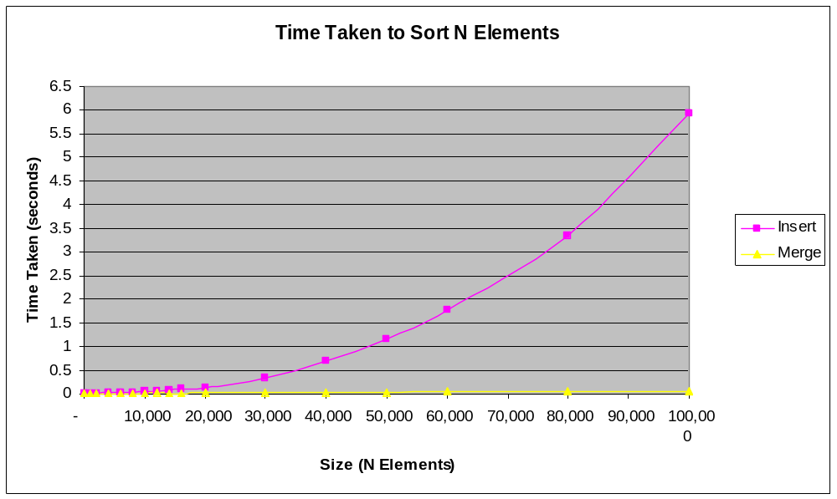

Size | Insert (Time) | Merge (Time)
10 | 0 | 0
50 | 0 | 0
1,000 | 0 | 0
2,000 | 0 | 0
4,000 | 0.015 | 0
6,000 | 0.016 | 0
8,000 | 0.031 | 0
10,000 | 0.047 | 0
12,000 | 0.047 | 0.015
14,000 | 0.078 | 0
16,000 | 0.093 | 0
20,000 | 0.141 | 0.016
30,000 | 0.344 | 0.016
40,000 | 0.687 | 0.032
50,000 | 1.156 | 0.031
60,000 | 1.765 | 0.047
80,000 | 3.328 | 0.063
100,000 | 5.922 | 0.062

